Learn from what you’re good at
A good way of learning or getting better at something is to use skills and attitudes you already have, or to learn from experience.
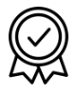 |  | What are three things you’re good at?
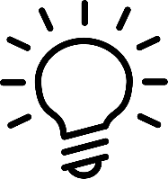 | How did you get good at these things? Think of strategies, methods or attitudes you used.

 | What do you want to improve?
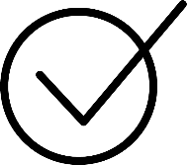 | How can you use the strategies, methods or attitudes from the things you’re good at to work on what you want to improve?

